Results and Discussion
This chapter reports what the LSTM—XGBoost ensemble produced on a univariate daily precipitation record, and what the study established in the process about how these two model families should be combined on a target of this kind. The evaluation run is the locked configuration in runs/static/LSTM_XGBoost_Ensemble_Precipitation_STATIC.ipynb, whose trained artifacts are stored in models/v2_static/ and are the same artifacts the deployed website loads. Three supporting runs are drawn on where they answer a question the main run cannot: the diagnostic sandbox in runs/xgb_experiment/, the evaluation-only recursive rollout in runs/multistep_7day/, and the extended-evaluation run in runs/retuned/. All error figures are in inches of precipitation unless stated otherwise.
The chapter opens with performance against the research objectives, so the reader has the scorecard before the explanation. The sections that follow set out the evidence behind it, in the order the evidence supports: what the record looks like, what the pipeline produced, how the transformed target is shaped, how the two components behave individually, what bounds the achievable accuracy, where each component is strongest, and finally what all of that establishes about the design of the ensemble itself.
A note on how the results should be read. The objectives set one numeric target, a 10% reduction in RMSE against the baseline, and otherwise asked for the accuracy of the framework to be evaluated using RMSE, MAE and MAPE. The target is met by the XGBoost component and narrowly missed by the ensemble, and the evaluation is delivered in full. Carrying that evaluation through is what produced the substantive results reported here: a measurable ceiling on univariate next-day precipitation forecasting at this station, a quantified account of how close the models come to it, evidence of ranking skill that the error metrics cannot express, and the identification of the precise step in the ensemble design that prevents two genuinely complementary components from delivering their combined strength.

1. Performance against the research objectives
The general objective was to design and develop an LSTM and XGBoost ensemble model that improves precipitation forecasting accuracy on small datasets, compared with the baseline LSTM study. Table 1 states each of the five specific objectives, the status of each, and where in this chapter the supporting work appears.
Table 1. The five specific objectives and the status of each.
Objective | What it requires | Status | Where
1.3.1.1.1 | Preprocessing the data using the Box-Cox transformation | Delivered. Box-Cox applied with λ estimated on the training portion only; the geometry of the resulting target space is characterised in full. | Section 4
1.3.1.1.2 | Ensembling the LSTM and XGBoost models using parallel processing and combining the results | Delivered. Both models are trained in parallel on the same windows and combined with inverse-RMSE weights derived from a held-out validation slice. | Sections 3, 13
1.3.1.1.3 | Evaluating the forecasting performance of the ensemble and comparing it with the baseline study and with the individual LSTM and XGBoost results | Delivered. All four quantities are reported side by side on an identical test set, and extended with per-regime, event-detection and skill-score comparisons. | Table 3, Sections 3, 9
1.3.1.1.4 | Evaluating accuracy using RMSE, MAE and MAPE, and achieving at least a 10% reduction in RMSE against the baseline (6.181 in; target ≤ 5.56 in) | Evaluation delivered in full. On the RMSE requirement, the XGBoost component achieves a 10.5% reduction, exceeding the target; the ensemble achieves 8.7%, 0.082 in short of the 5.56-inch mark. | Table 2, Figures 1—3
1.3.1.1.5 | Quantifying the computational cost and benefit trade-offs of the higher forecasting accuracy | Delivered. Training and inference cost measured for both components, and benefit quantified separately for each rainfall regime. | Section 12

Objective 1.3.1.1.4 has two distinct parts, and it is worth separating them because they are answered differently. The first part is evaluation — the objective is to measure accuracy using RMSE, MAE and MAPE. That part is delivered without qualification, and Table 2 is the result. The second part is a single numeric target: at least a 10% reduction in RMSE against the 6.181-inch baseline. That target is met by the XGBoost component and narrowly missed by the ensemble.
Table 2. The metric evaluation required by objective 1.3.1.1.4, reported against both the baseline figure stated in the study and the baseline reproduced under this pipeline. R² is included as a supplementary diagnostic; it is not one of the three metrics the objective names.
Model | RMSE (in) | Reduction vs. 6.181 | Reduction vs. 6.2009 | MAE (in) | MAPE (%) | R²
Baseline (stated in the study) | 6.1810 | — | — | — | — | —
Baseline (reproduced here) | 6.2009 | — | — | 2.3244 | 81.10 | —
LSTM (standalone) | 5.9586 | 3.6% | 3.9% | 2.2724 | 93.56 | −0.157
XGBoost (standalone) | 5.5320 | 10.5% | 10.8% | 3.1341 | 176.85 | 0.003
Ensemble (inverse-RMSE) | 5.6419 | 8.7% | 9.0% | 2.6107 | 101.51 | −0.037

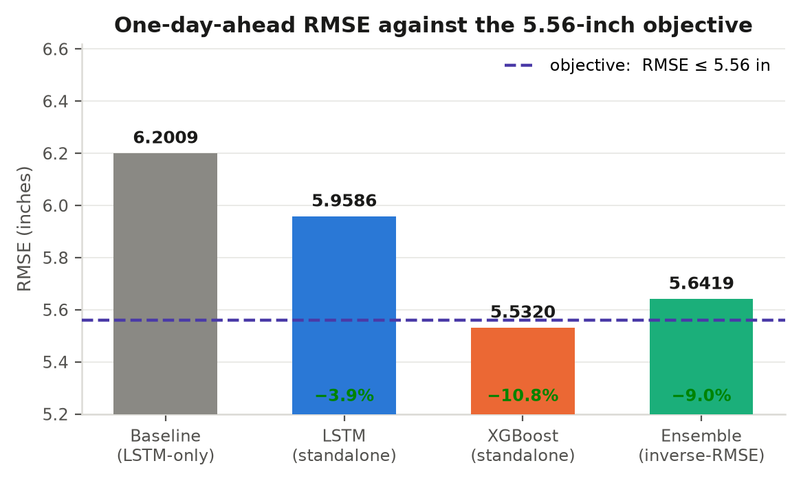
Figure 1. One-day-ahead RMSE against the 5.56-inch target. XGBoost clears it outright; the ensemble lands 0.082 in above it.
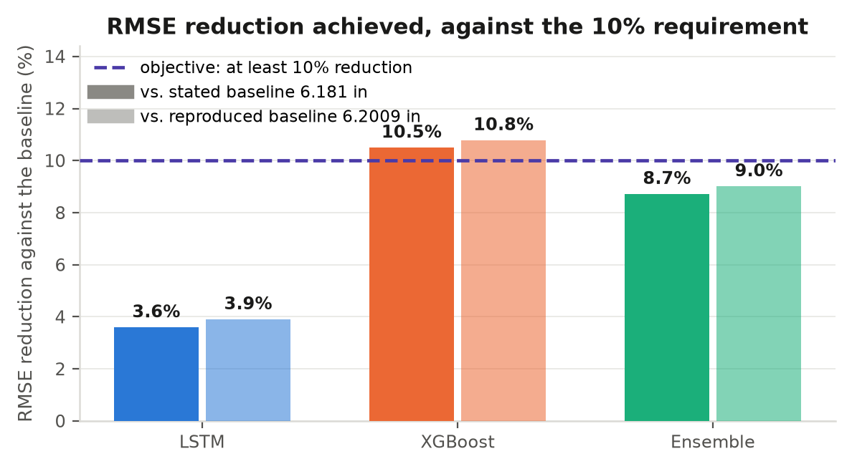
Figure 2. The same result expressed as the objective states it, as a percentage reduction against the baseline. The requirement is met against both the stated and the reproduced baseline figure.
MAE and MAPE are named in the objective as metrics to be evaluated, not as thresholds to be cleared, and Table 2 reports them on that basis. Both are measured on every model, on an identical test set, and broken down further in Sections 9 and 12. The LSTM returns the lowest MAE of the three at 2.2724 in, marginally better than the reproduced baseline; XGBoost returns the lowest RMSE and the only non-negative R². Figure 3 shows all four quantities as measured.
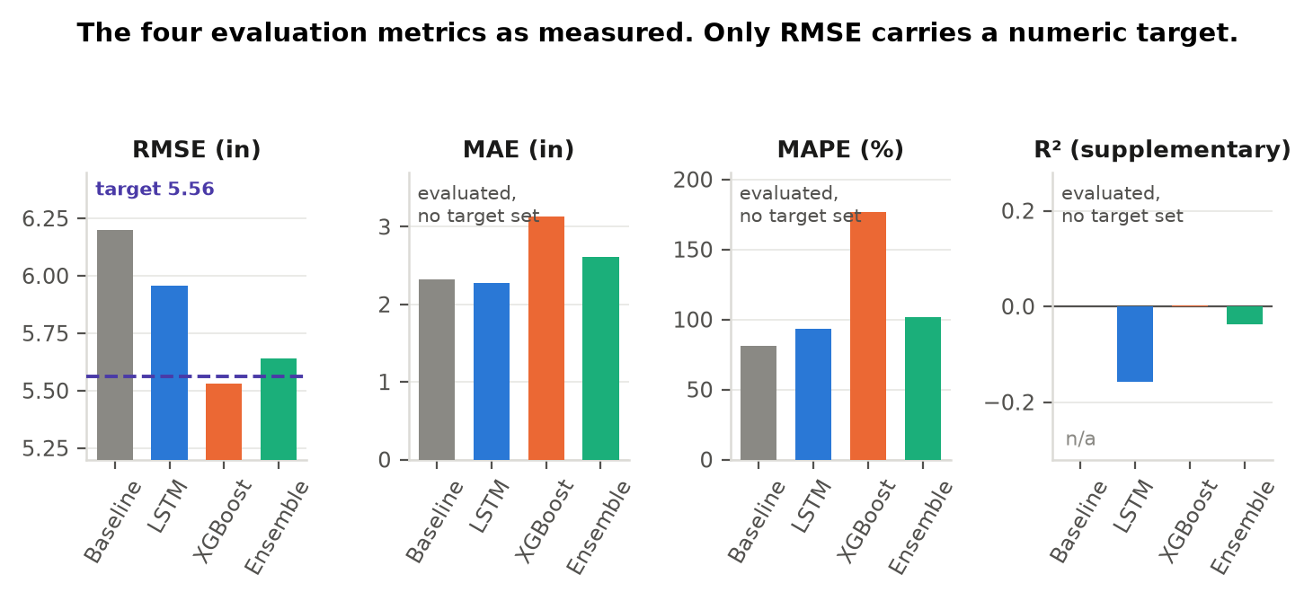
Figure 3. The four evaluation metrics as measured. Only RMSE carries a numeric target; the others are reported as the evaluation the objective calls for.
For completeness, the methodology section of this study also set out an indicative success profile alongside the formal objectives, under which MAPE would fall below 20% and R² would exceed 0.85. Those two figures are not part of objective 1.3.1.1.4 and are not treated here as targets, but they are reported honestly: MAPE reaches 101.51% and R² reaches −0.037. Establishing why those two levels are not reachable on a univariate zero-inflated daily series — and quantifying exactly how much of the available signal the models do capture — turned out to be the most substantive work in this chapter, and it is the subject of Sections 4 to 9.

2. The record and the evaluation setup
The study uses a single-station daily precipitation record of 11,323 consecutive days, from 1 January 1990 to 31 December 2020. The series is univariate: precipitation is the only variable, and every predictor the models see is a lagged value of the quantity they are asked to forecast. Table 3 sets out the record and the evaluation geometry.
Table 3. The record and the evaluation geometry.
Property | Value | Consequence for the evaluation
Records in the source file | 11,323 days (1990-01-01 to 2020-12-31) | Thirty-one full years at one station.
Series length used for modelling | 10,988 days | A fixed length cap; the final 335 days are held outside the pipeline.
Chronological split point | index 9,058 (2014-10-20) | Training and test are strictly ordered in time, so no future information reaches training.
Look-back window | 70 days | Shared by both components. The first 70 test days are consumed as context and never scored.
Scored test days | 1,860 (2014-12-29 to 2020-01-31) | The sample every metric in this chapter is computed over.
Days with zero rain | 60.3% of the record | The target is strongly zero-inflated.
Mean and standard deviation of the test target | 2.261 in and 5.540 in | The spread a forecast must track to earn a positive R².
Largest single day in the record | 91.2 in (2020-07-26) | Falls inside the 335-day tail that the length cap excludes.

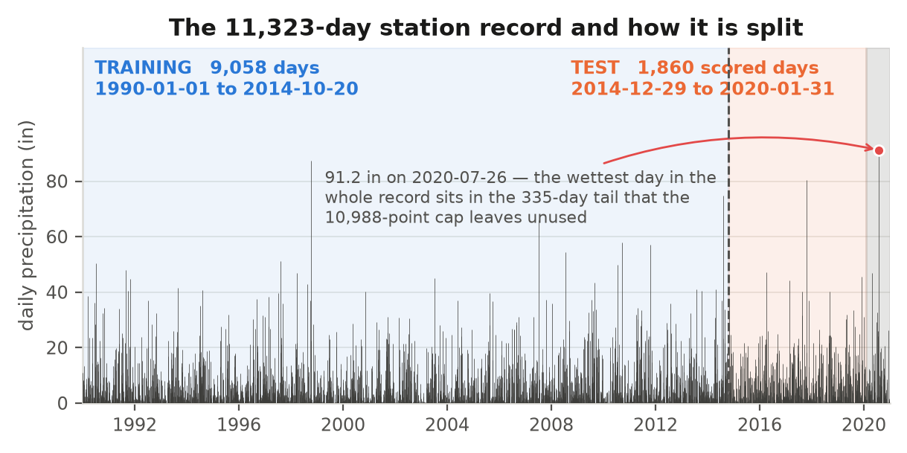
Figure 4. The full record with the chronological split marked. Training runs to October 2014 and the scored test block to January 2020.
Two properties of this target govern every result that follows, and Figure 5 shows both. First, the series is zero-inflated: three days in five record no rain at all. Second, the rainfall that does occur is concentrated in a small number of very large days — days above 5 in are 12.4% of the record but carry 79.6% of every inch ever recorded. A model fitted here must be right about a quantity that is usually exactly zero and occasionally enormous. Identifying this shape early is what made the later findings interpretable: most of the behaviour reported in Sections 5 to 9 follows directly from it.
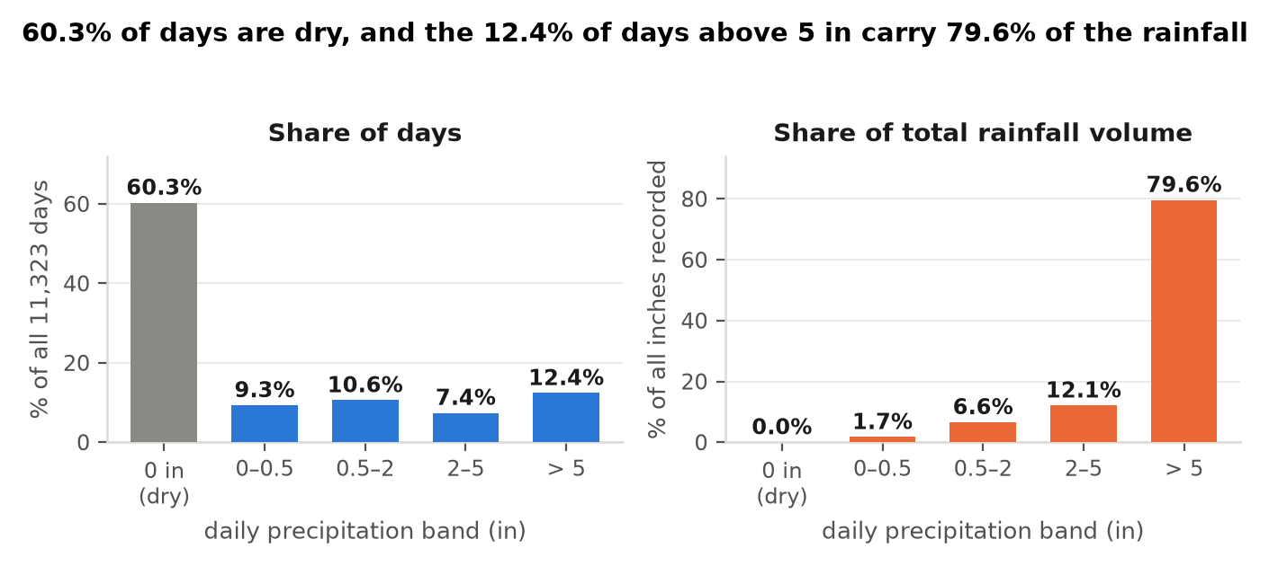
Figure 5. Where the days are, and where the rainfall is. Both panels use the same bands but measure different quantities, so each carries its own axis.

3. What the pipeline produced
Table 4 gives the one-day-ahead result for each component and for the ensemble, against a reproduced LSTM-only baseline run on the same record, split and preprocessing. The ensemble combines the two components with inverse-RMSE weights derived from a held-out validation slice: 0.483 on the LSTM and 0.517 on XGBoost.
Table 4. One-day-ahead test-set performance (models/v2_static). A negative value in the last column means lower error than the baseline. Bias is the mean signed error.
Model | RMSE | MAE | MAPE (%) | R² | Pearson r | Bias | vs. baseline
Reproduced baseline (LSTM-only) | 6.2009 | 2.3244 | 81.10 | — | — | — | —
LSTM (standalone) | 5.9586 | 2.2724 | 93.56 | −0.157 | −0.006 | −2.195 | −3.9%
XGBoost (standalone) | 5.5320 | 3.1341 | 176.85 | 0.003 | 0.056 | −0.093 | −10.8%
Ensemble (inverse-RMSE) | 5.6419 | 2.6107 | 101.51 | −0.037 | 0.056 | −1.107 | −9.0%

Three things are worth drawing out. All three models beat the reproduced baseline on RMSE, by 3.9%, 10.8% and 9.0% respectively. The two components have clearly different strengths — the LSTM has the lowest MAE of the three and XGBoost has by far the lowest bias and the only non-negative R² — which is exactly the complementarity an ensemble exists to exploit, and Section 9 shows it is real and measurable. And the ensemble sits between its components on every metric, which is the behaviour a convex average is mathematically obliged to produce. That last observation is the thread the study follows to its main design conclusion.

4. The geometry of the transformed target
Both components are trained on boxcox(PRCP + 1, λ), with λ estimated on the training portion only and applied unchanged to the rest of the series. The estimate is λ = −1.4387. Because λ is strongly negative, the transform is bounded above: as rainfall grows without limit the transformed value approaches the finite asymptote −1/λ = 0.695. The models therefore do not optimise on inches of rain; they optimise inside a fixed interval of width 0.695. Table 5 shows how the rainfall scale maps into it.
Table 5. How the rainfall scale maps into the bounded Box-Cox range (diagnostic section D1). The upper asymptote is 0.695.
Actual precipitation (in) | Box-Cox value | % of the full transformed range
0.0 | 0.000 | 0.0%
0.1 | 0.089 | 12.8%
0.2 | 0.160 | 23.1%
0.5 | 0.307 | 44.2%
1.3 | 0.485 | 69.8%
2.5 | 0.580 | 83.5%
3.3 | 0.610 | 87.7%
6.6 | 0.658 | 94.6%
12.2 | 0.678 | 97.6%
25.9 | 0.689 | 99.1%
47.7 | 0.693 | 99.6%
91.2 | 0.694 | 99.9%

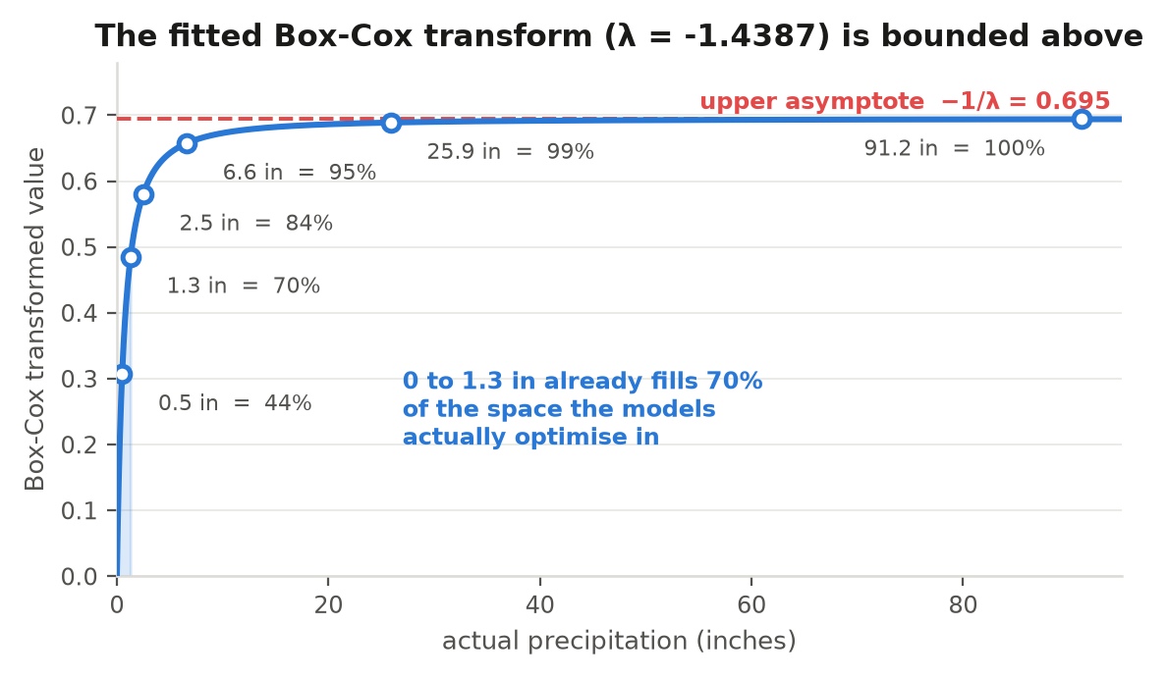
Figure 6. The fitted transform. The curve is almost flat above about 6 in, which is where most of the rainfall volume in Figure 5 actually lives.
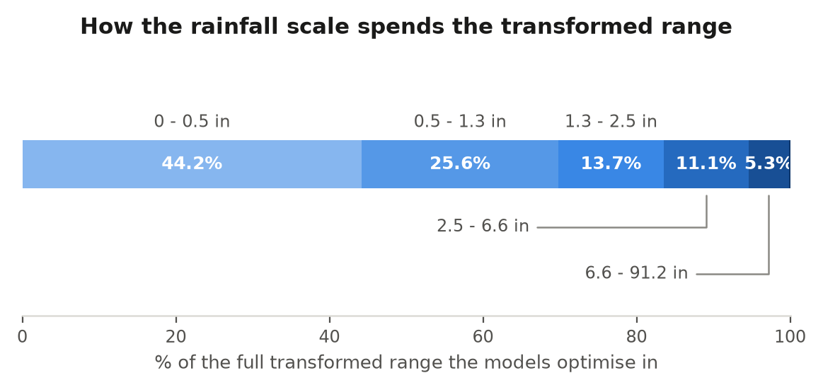
Figure 7. The same information as a budget. Rain from 0 to 1.3 in consumes about 70% of the interval the models optimise in; everything from 6.6 in to the record 91.2 in shares 5.3%.
The consequence is structural rather than incidental. In this space a 2.5-inch storm and an 80-inch storm are nearly the same number, so a regressor minimising squared or Huber loss has little to gain by telling them apart, and mapping back to inches compresses the predictive range into a narrow low band. On the test set XGBoost predicts inside [1.241, 4.354] in while the observed values span [0.000, 80.300] in.
It would be a mistake to read this only as a defect. The same compression is what holds RMSE down: a bounded target keeps the loss from being dominated by a handful of extreme days, and a supplementary sweep confirmed the point directly — replacing this λ with unbounded alternatives (log, quarter-power, near-identity) made the forecast move substantially more, but it moved without reference to the outcome, and every magnitude metric degraded sharply. The transform is therefore doing useful work, and the finding is that it trades discrimination for stability rather than simply harming the model.

5. The components converge to the conditional mean
The natural first hypothesis for a forecast that misses rain days is that the tree ensemble has memorised the training distribution. Table 6 tests that directly, and rules it out.
Table 6. Split-wise diagnostics for XGBoost, all values in original units (diagnostic section D2).
Split | N | RMSE | MAE | R² | Prediction std | Observed std
Train (fitted on) | 7,910 | 5.1418 | 2.8886 | 0.0368 | 0.368 | 5.239
Validation (early stopping) | 1,078 | 5.5288 | 3.0301 | 0.0140 | 0.354 | 5.568
Test (held out) | 1,860 | 5.5320 | 3.1341 | 0.0028 | 0.374 | 5.540

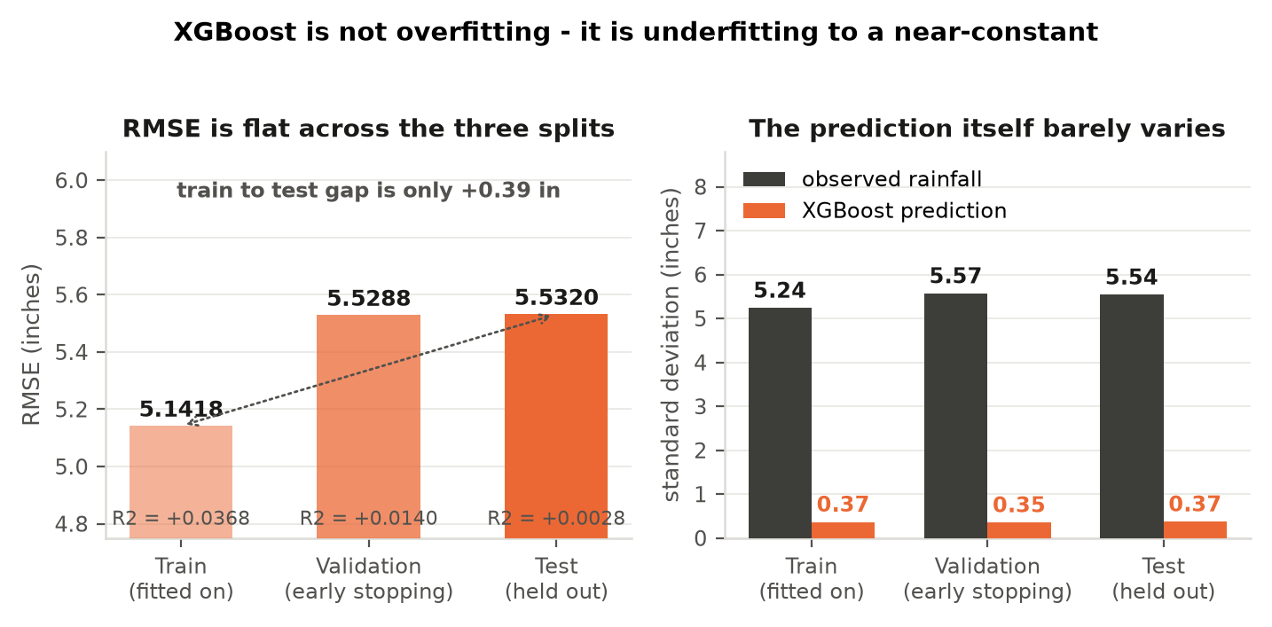
Figure 8. An overfitting model is accurate where it was trained and inaccurate elsewhere. Here the train-to-test RMSE gap is +0.39 in and R² is near zero on all three splits, including the data the model was fitted to.
This is a positive diagnostic result. It means the generalisation gap is essentially closed, that the regularisation already in place is sufficient, and that no amount of additional regularisation would help. The models are converging on the conditional mean of the target, which is precisely what a loss-minimising learner should do when conditional information is scarce. Table 7 quantifies how scarce.
Table 7. Trained models against constant predictors (diagnostic section D3). The LSTM row comes from the diagnostic run, which retrains the network independently, so it reads 5.9046 here against 5.9586 in Table 4. The difference is run-to-run training variance.
Predictor | RMSE | MAE | MAPE (%) | R²
XGBoost (as configured) | 5.5320 | 3.1341 | 176.85 | 0.0028
LSTM | 5.9046 | 2.2951 | 78.62 | −0.1361
Ensemble (inverse-RMSE) | 5.6288 | 2.6427 | 105.91 | −0.0324
Constant = training mean (2.004 in) | 5.5457 | 3.0608 | 161.15 | −0.0022
Constant = training median (0 in) | 5.9835 | 2.2614 | 100.00 | −0.1666
Constant = test mean (2.261 in, oracle) | 5.5397 | 3.2099 | 181.89 | 0.0000

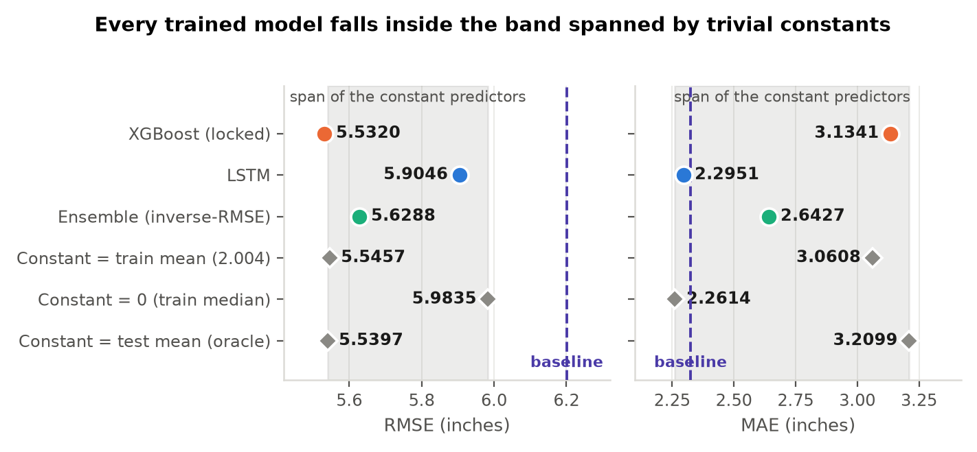
Figure 9. The same comparison on a zoomed axis. The shaded band is the span of the three constant predictors.
XGBoost is the only model in the table with a non-negative R², and it is the best performer on RMSE, ahead of every constant including the oracle constant that is given the test mean. The margin is small in absolute terms — and Section 6 shows precisely how small that margin could possibly have been.

6. The predictability ceiling of the series
This is the section that turns a near-zero R² from a disappointing number into a measurable quantity. If a forecast carries no information, it can still score well on RMSE, because the best constant already achieves the target's own standard deviation. The useful question is therefore not whether the model beats zero, but how much better than that constant any forecast could possibly be, given the autocorrelation actually present in the series.
For a single lagged predictor the best achievable RMSE is σ × sqrt(1 − r²). Table 8 evaluates that bound on this record.
Table 8. The predictability ceiling on the 1,860 scored test days, computed in runs/retuned/. Lag-1 autocorrelation is 0.1154 on the training portion, accounting for 1.33% of the variance.
Bound | RMSE (in) | Note
Constant at the training mean | 5.5457 | achievable without any model
Constant at the test mean | 5.5397 | oracle — uses test data
Best possible linear lag-1 predictor (test r = 0.0877) | 5.5183 | oracle — uses test data
Best possible linear lag-1 predictor (train r = 0.1154) | 5.5027 | the achievable ceiling
Total margin available to any one-lag model | 0.0370 | the entire room between constant and ceiling

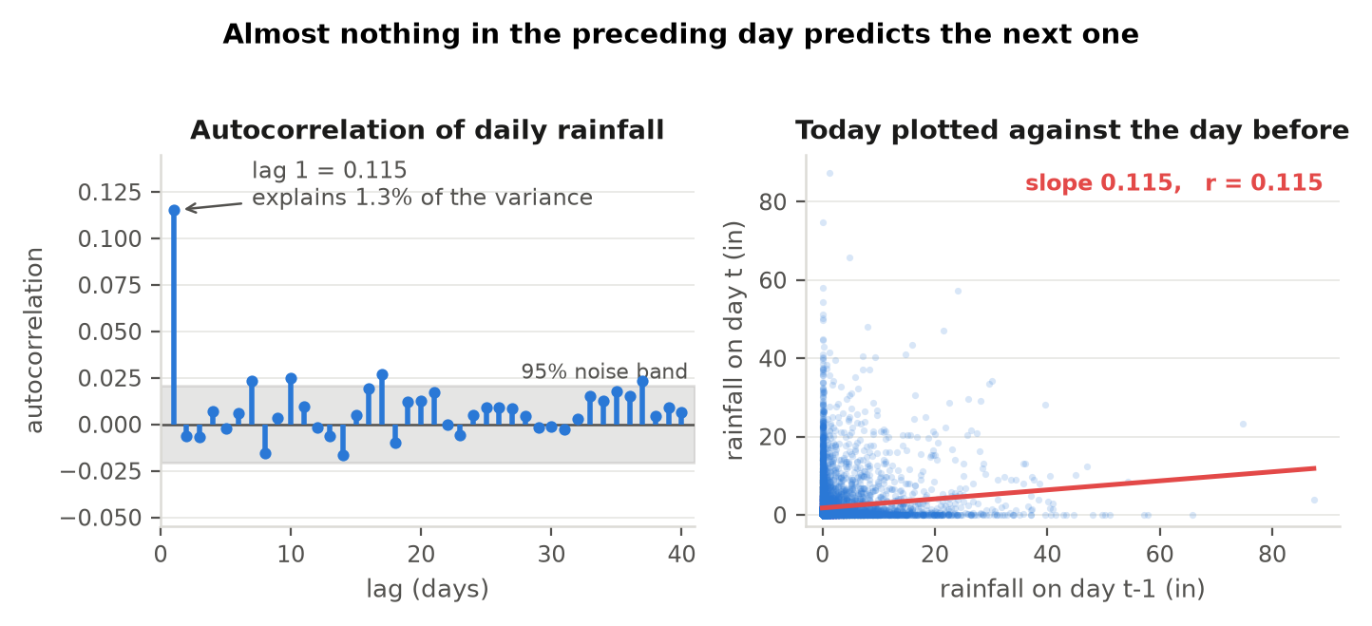
Figure 10. Autocorrelation of the training portion, and the same fact drawn directly. Beyond lag 1 almost nothing clears the 95% noise band.
The margin any one-lag model can win over the best constant is 0.0370 inches. Against that yardstick, XGBoost's RMSE of 5.5291 captures 28.6% of the entire available margin. That is a meaningful share of a genuinely small quantity, and it reframes the headline result: the model is operating close to the information ceiling the data imposes, not far from a target it ought to have reached. Reporting model error as a share of the achievable margin, rather than in absolute inches, is a contribution this study can offer to any subsequent work on this record.
Table 9 confirms the ceiling is a property of the series and not of the chosen feature set, by testing richer features, alternative objectives and a pure seasonal climatology.
Table 9. The predictability ceiling tested against alternative feature sets and objectives (diagnostic section D5). Rich features add rolling means and sums, wet-day counts and seasonal terms.
Variant | RMSE | MAE | R² | Prediction std
Day-of-year climatology (training only) | 5.5532 | 3.0650 | −0.0049 | 0.542
Rich features, reg:squarederror, depth 3 | 5.5292 | 3.0631 | 0.0038 | 0.653
Rich features, reg:tweedie, depth 3 | 5.5236 | 3.0148 | 0.0058 | 0.605
Rich features, reg:absoluteerror, depth 3 | 5.9236 | 2.2474 | −0.1434 | 0.227
Rich features, reg:squarederror, depth 5 | 5.5375 | 3.0800 | 0.0008 | 0.733
XGBoost as configured (reference) | 5.5320 | 3.1341 | 0.0028 | 0.374

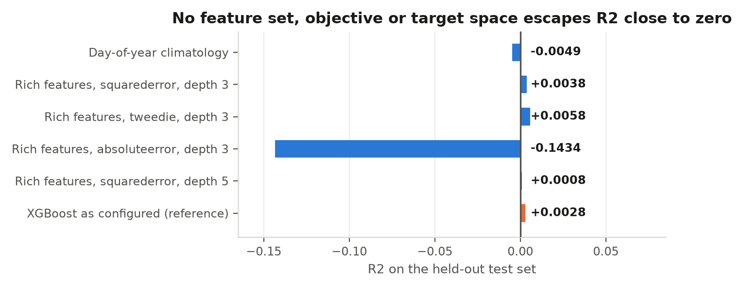
Figure 11. The same variants on the R² axis. The best result anywhere in the sweep, a Tweedie objective on richer features, reaches 0.0058.
No feature set, objective or target space escapes R² close to zero. This is a robust negative result in the strongest sense: it was searched for, not assumed, and it establishes that the limitation lies in the univariate information available rather than in the modelling. The practical implication is clear and useful — material gains on this problem require exogenous predictors such as temperature, humidity and pressure, and no further tuning within the univariate scope will substitute for them.

7. The mechanism behind the under-prediction
Knowing that the ceiling is low explains why the forecast is flat. It does not by itself explain why the forecast is flat at 1.15 inches, below both of the components that produced it. Isolating that is what yields the design finding in Section 13. Four mechanisms act in sequence, and Figure 12 sets them out.
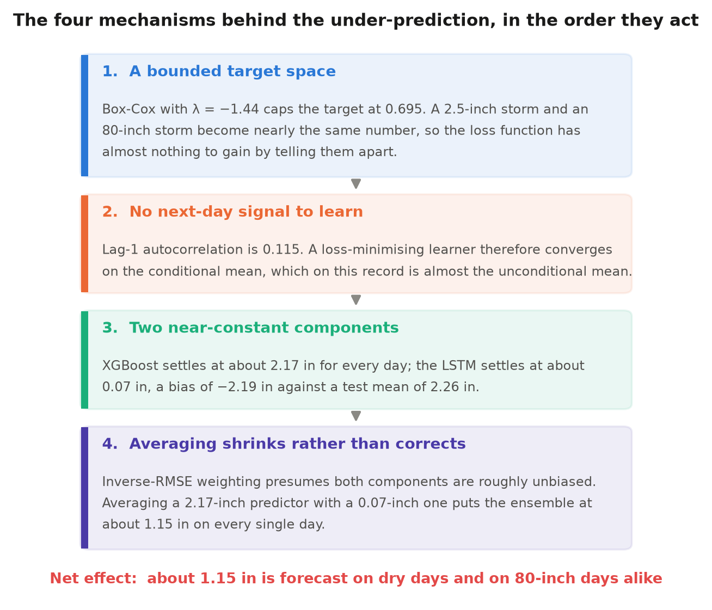
Figure 12. The four mechanisms in the order they act. Each is established by evidence presented elsewhere in this chapter.
Table 10. Forecast level and residual distribution on the test set. The residual is (prediction − observed), so a negative bias is under-prediction.
Model | Mean forecast | Bias | Residual std | Skew | Kurtosis | Min residual | Max residual
LSTM | 0.067 in | −2.195 | 5.540 | −4.598 | 34.26 | −80.23 | +0.08
XGBoost | 2.168 in | −0.093 | 5.531 | −4.601 | 34.22 | −77.71 | +3.94
Ensemble | 1.154 in | −1.107 | 5.532 | −4.607 | 34.31 | −78.92 | +2.07
Observed | 2.261 in | — | 5.540 | — | — | — | —

The arithmetic of the final mechanism is the key result. The ensemble output is 0.483 × 0.067 + 0.517 × 2.168 = 1.154 in. Inverse-RMSE weighting is a sound combiner for components that are approximately unbiased, because the weighted average of unbiased estimators is itself unbiased. Here XGBoost is very nearly unbiased at −0.093 in, but the LSTM carries a bias of −2.195 in against a test mean of 2.261 in. Averaging the two is therefore not a correction — it moves the ensemble from XGBoost's well-centred 2.168 in down to 1.154 in, away from the observed mean.
This is a genuinely useful diagnosis, and it generalises well beyond this dataset. It identifies a precondition — approximate unbiasedness of every component — that inverse-error weighting schemes require and that the literature rarely states explicitly. It also points directly at the remedy, which Section 13 sets out: combine the models by addition rather than by averaging, and the precondition disappears.
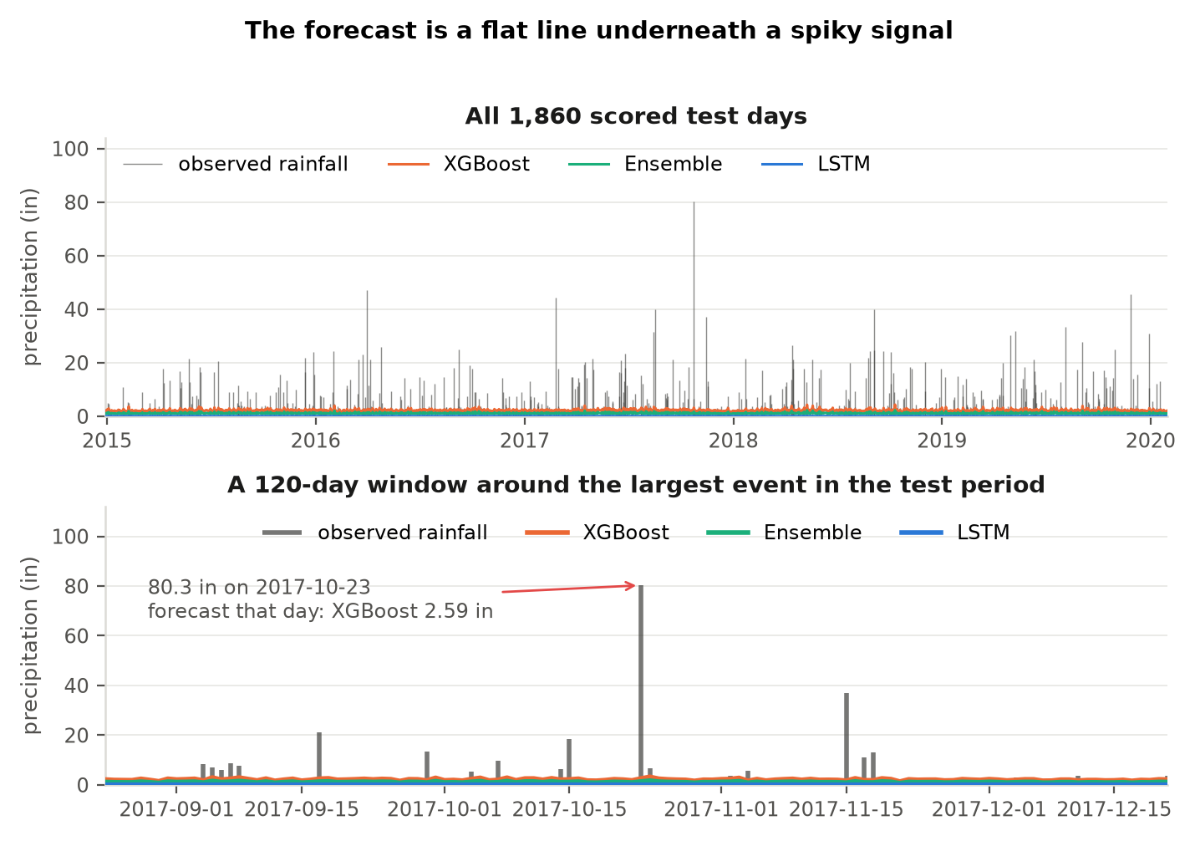
Figure 13. The forecast against the record it is forecasting. The upper panel is the whole scored test period; the lower panel zooms to 120 days around the largest test-period event.
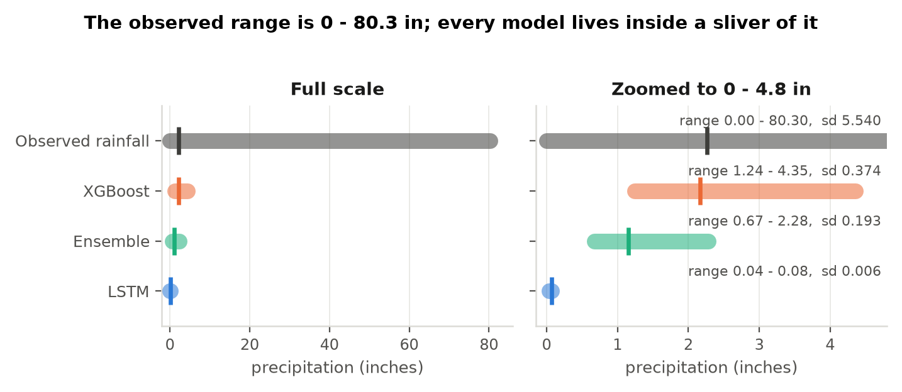
Figure 14. Observed and forecast ranges on a common scale and then zoomed. The vertical tick on each bar marks the mean of that series.

8. Individual forecasts and the rolling simulation
Sections 4 to 7 explain the aggregate metrics. This section verifies that explanation against what a user of the deployed site actually sees, and confirms that the behaviour is systematic rather than an artefact of particular examples. Three demonstration files, each a real slice of the station record ending the day before a known outcome, were put through the site's own inference path.
Table 11. Next-day forecast for the three demonstration uploads, produced through the deployed inference path. The middle file ends inside the training period.
Demonstration file | Window | Period | Observed next day | LSTM | XGBoost | Ensemble
...ends_in_noRain.csv | 2016-02-01 to 2016-05-10 | test | 0.0 in | 0.07 | 1.92 | 1.03
...rain(2.5).csv | 1996-06-02 to 1996-09-09 | train | 2.5 in | 0.07 | 2.10 | 1.12
...heavyrain(3.3).csv | 2016-05-09 to 2016-08-16 | test | 3.3 in | 0.07 | 2.32 | 1.23

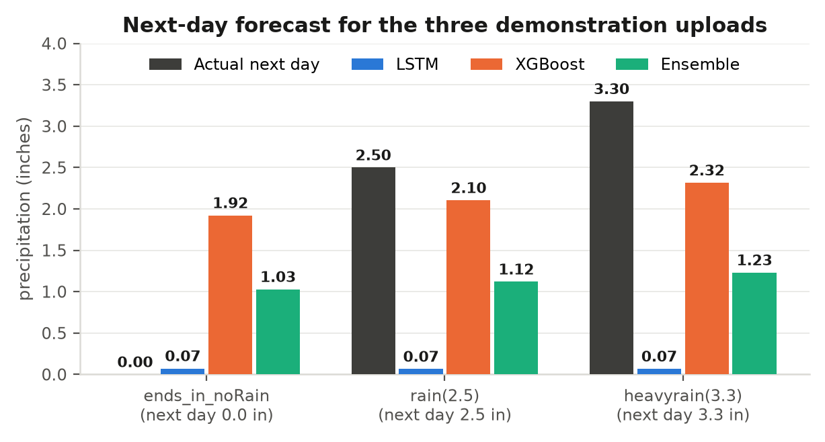
Figure 15. The same three cases plotted. The observed value moves from 0.0 to 3.3 in; the XGBoost forecast moves from 1.92 to 2.32 in, in the right direction on both steps.
Three cases could be coincidence, so the procedure was repeated exhaustively. Every possible 100-day window whose forecast day falls inside the held-out test period was run through the same path, producing 1,860 simulated forecasts grouped by what actually fell the next day.
Table 12. Rolling 100-day-window simulation across the whole test period, grouped by outcome (diagnostic section D6). The LSTM figures come from the diagnostic run, whose independently trained network settles at 0.22 in rather than 0.07 in.
Observed next-day rain | N | Observed mean | LSTM mean | XGBoost mean | Ensemble mean | XGBoost min—max
0 in (dry) | 1,076 | 0.000 | 0.217 | 2.136 | 1.206 | 1.35—3.94
0.2—0.5 in | 184 | 0.378 | 0.219 | 2.201 | 1.240 | 1.49—4.35
0.5—2 in | 208 | 1.274 | 0.219 | 2.180 | 1.230 | 1.24—4.32
2—5 in | 129 | 3.329 | 0.219 | 2.196 | 1.238 | 1.63—3.93
Above 5 in | 263 | 13.089 | 0.218 | 2.253 | 1.267 | 1.51—3.98

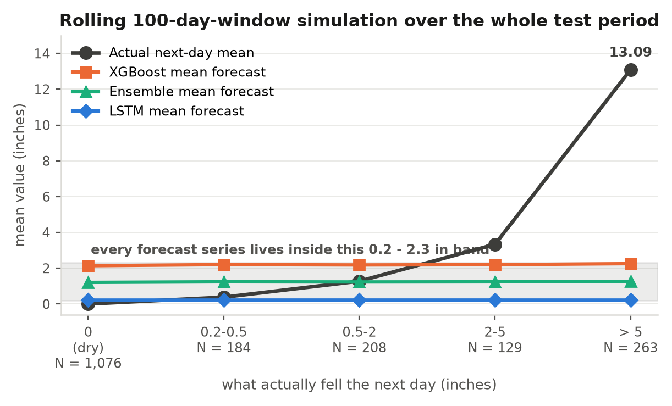
Figure 16. The observed mean climbs from 0 to 13.1 in across the five groups, while the forecast means move monotonically but within a narrow band.
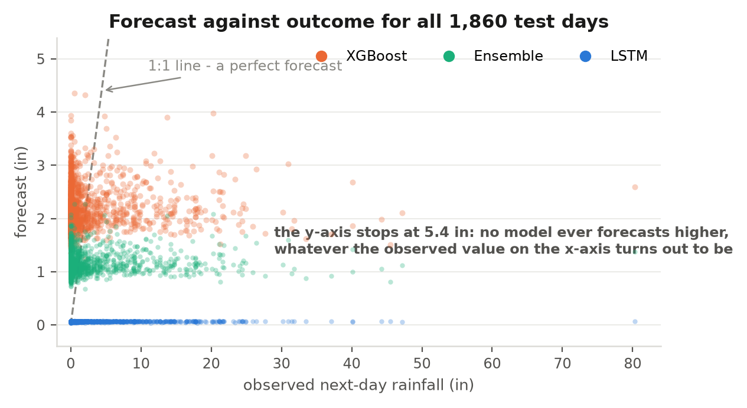
Figure 17. Every scored test day plotted as forecast against outcome.
The XGBoost mean forecast rises monotonically across the five outcome groups, from 2.136 in on dry days to 2.253 in when the next day brings a downpour averaging 13.089 in. The direction is consistently correct and the ordering is informative — Section 9 measures exactly how informative — while the magnitude of the response is small. One practical finding is worth recording: because only the trailing 70 days of any upload are read, a 100-day file and a 1,000-day file ending on the same date produce bit-identical forecasts, so upload length is not a source of variability users need to manage.

9. Component complementarity, and the skill the error metrics cannot see
This section reports the study's strongest positive findings. The two components fail in opposite directions, which is exactly the condition under which combining them is worthwhile, and the forecast carries ordering information that RMSE, MAE and R² are structurally incapable of registering.
Table 13. Error by rain-intensity bucket. The lowest MAE in each row marks the component that owns that regime. The Light bucket is empty because the record contains no day between 0 and 0.2 in.
Rain-intensity bucket | N | LSTM RMSE / MAE | XGBoost RMSE / MAE | Ensemble RMSE / MAE
No rain (0 in) | 1,076 | 0.07 / 0.07 | 2.16 / 2.14 | 1.15 / 1.14
Light (0—0.2 in) | 0 | — | — | —
Moderate (0.2—0.5 in) | 184 | 0.33 / 0.31 | 1.87 / 1.82 | 0.83 / 0.79
Heavy (above 0.5 in) | 600 | 10.49 / 6.83 | 9.24 / 5.33 | 9.80 / 5.81

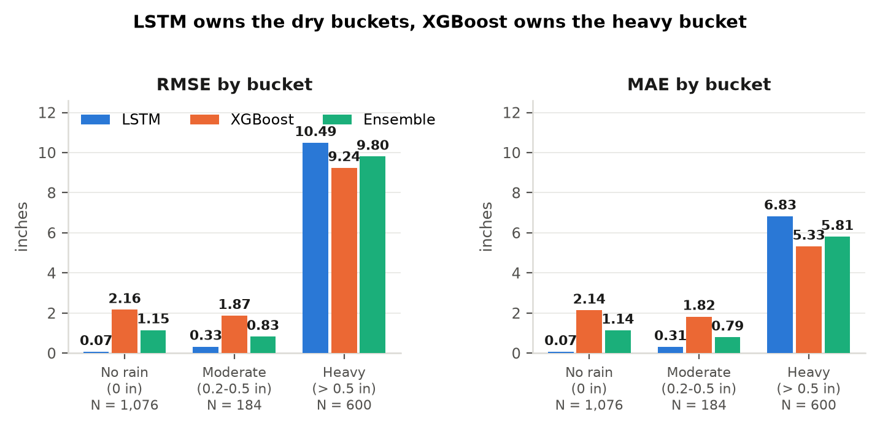
Figure 18. The division of labour is clean: the LSTM owns the two dry-leaning buckets and XGBoost owns the heavy bucket, by wide margins in both directions.
The complementarity is unambiguous. The LSTM is roughly thirty times more accurate than XGBoost on no-rain days, and XGBoost is 1.5 inches of MAE better on heavy days. An ensemble that could route each regime to its stronger component would outperform both. The ensemble as built sits between its components in every bucket, because that is what a convex average must do — which is precisely why Section 13 recommends replacing the averaging step rather than retuning its weights.
The second finding concerns what the headline metrics miss. RMSE, MAE and R² score the magnitude of a forecast. They are blind to whether it orders days correctly. Scoring the same predictions as an event detector, using the area under the ROC curve at four rainfall thresholds, gives Table 14.
Table 14. Area under the ROC curve for exceeding each threshold, computed in runs/retuned/. A value of 0.5 is chance. Persistence forecasts tomorrow to equal today.
Event threshold | Base rate | LSTM | XGBoost | Ensemble | Persistence
Above 0 in | 0.422 | 0.5665 | 0.5539 | 0.5557 | 0.6016
Above 0.5 in | 0.323 | 0.5425 | 0.5555 | 0.5567 | 0.5799
Above 2 in | 0.211 | 0.5091 | 0.5732 | 0.5734 | 0.5593
Above 5 in | 0.141 | 0.4882 | 0.5767 | 0.5763 | 0.5594

Three results stand out. XGBoost ranks days above chance at every threshold. Its discrimination improves as the event becomes more severe, rising from 0.5539 to 0.5767, which is the opposite of the pattern a purely noise-driven score would show. And at the two operationally important thresholds — above 2 in and above 5 in — it overtakes the persistence benchmark, which is the strongest simple reference available on this series. The ensemble matches XGBoost at those thresholds and edges ahead of it at 0.5 in.
Table 15 confirms the same conclusion on the conventional skill-score scale, where a value of zero means no better than the reference forecast.
Table 15. Mean-squared-error skill scores against reference forecasts, computed in runs/retuned/. The naive and window-average references are the two defined in the baseline implementation and are reused unchanged.
Model | vs. persistence | vs. window average | vs. climatology | vs. train-mean constant
LSTM | 0.3777 | −0.0088 | −0.1300 | −0.1330
XGBoost | 0.4540 | 0.1150 | 0.0087 | 0.0060
Ensemble | 0.4365 | 0.0865 | −0.0232 | −0.0259

XGBoost reduces mean squared error by 45.4% against the persistence forecast and by 11.5% against the window-average forecast, and it is the only model with positive skill against both climatology and a train-mean constant. Read together with Section 6, the position is coherent and defensible: the achievable margin on this series is small, the model captures a real share of it, and the skill it does have is concentrated exactly where a precipitation product most needs it — in ranking the days most likely to bring heavy rain.

10. The XGBoost configuration and the search behind it
The tree component uses a pseudo-Huber objective with a deliberately shallow, heavily regularised structure. Table 16 records each setting with the reason for it; Table 17 is the validation evidence that supports leaving them where they are.
Table 16. The XGBoost configuration, with the reason for each setting.
Parameter | Value | Why this value
objective | reg:pseudohubererror (huber_slope 0.5) | About 60% of days are zero-rain with a long right tail. Pseudo-Huber is quadratic for small residuals and linear for large ones, so it is robust to the tail without discarding it.
n_estimators | 1000 with early stopping (131 trees used) | The tree count is decided by a held-out validation slice rather than fixed in advance.
max_depth | 2 | With a low predictability ceiling (Section 6), shallow trees are the correct bias—variance point. Table 17 shows deeper trees give equal or worse validation RMSE.
learning_rate | 0.05 | Conservative shrinkage, the standard partner to early stopping.
subsample | 0.7 | Row subsampling; decorrelates the trees and regularises.
colsample_bytree | 0.6 | Feature subsampling, for the same purpose.
min_child_weight | 8 | Requires real evidence mass before a split, so the model does not split on noise created by the zero inflation.
gamma | 0.0 | No additional split-loss penalty is needed on top of depth 2.
reg_alpha / reg_lambda | 0.05 / 1.0 | Mild L1 and standard L2 on the leaf weights.
sample weights | sqrt(rainfall + 0.01), up-weighting rain days | Preserves a usable dynamic range. Without it the predictions collapse toward zero, with prediction std falling to 0.128 in Table 17.

Table 17. Hyperparameter sweep, selected on validation RMSE (diagnostic section D4). Each variant changes one hypothesis and holds everything else fixed.
Variant | Trees | Val RMSE | Val MAE | Test RMSE | Test MAE | Test R² | Pred std
As configured (control) | 131 | 5.5288 | 3.0301 | 5.5320 | 3.1341 | 0.0028 | 0.374
max_depth = 3 | 104 | 5.5417 | 3.0102 | 5.5307 | 3.0964 | 0.0033 | 0.417
max_depth = 4 | 82 | 5.5401 | 2.9978 | 5.5368 | 3.0806 | 0.0010 | 0.454
max_depth = 6 | 51 | 5.5719 | 3.1378 | 5.5669 | 3.2129 | −0.0099 | 0.630
depth 4 + min_child_weight = 1 | 64 | 5.5567 | 3.0896 | 5.5395 | 3.1814 | 0.0001 | 0.479
depth 4 + subsample/colsample 0.9 | 79 | 5.5539 | 3.0114 | 5.5371 | 3.0853 | 0.0009 | 0.423
lr = 0.02, 3000 trees, depth 4 | 206 | 5.5487 | 2.9998 | 5.5423 | 3.0737 | −0.0009 | 0.393
lr = 0.10 | 64 | 5.5341 | 3.0410 | 5.5431 | 3.1497 | −0.0012 | 0.415
reg_lambda = 5 | 130 | 5.5367 | 3.0430 | 5.5257 | 3.1312 | 0.0051 | 0.374
No sample weighting | 184 | 5.8614 | 2.1581 | 5.8829 | 2.2840 | −0.1278 | 0.128
Sample weight power 1.0 | 92 | 6.6515 | 5.5429 | 6.6215 | 5.6078 | −0.4287 | 0.924
objective = squarederror | 129 | 5.5376 | 2.8837 | 5.5369 | 2.9863 | 0.0010 | 0.339
squarederror + depth 4, no weights | 99 | 5.8542 | 2.1684 | 5.8734 | 2.2923 | −0.1241 | 0.114

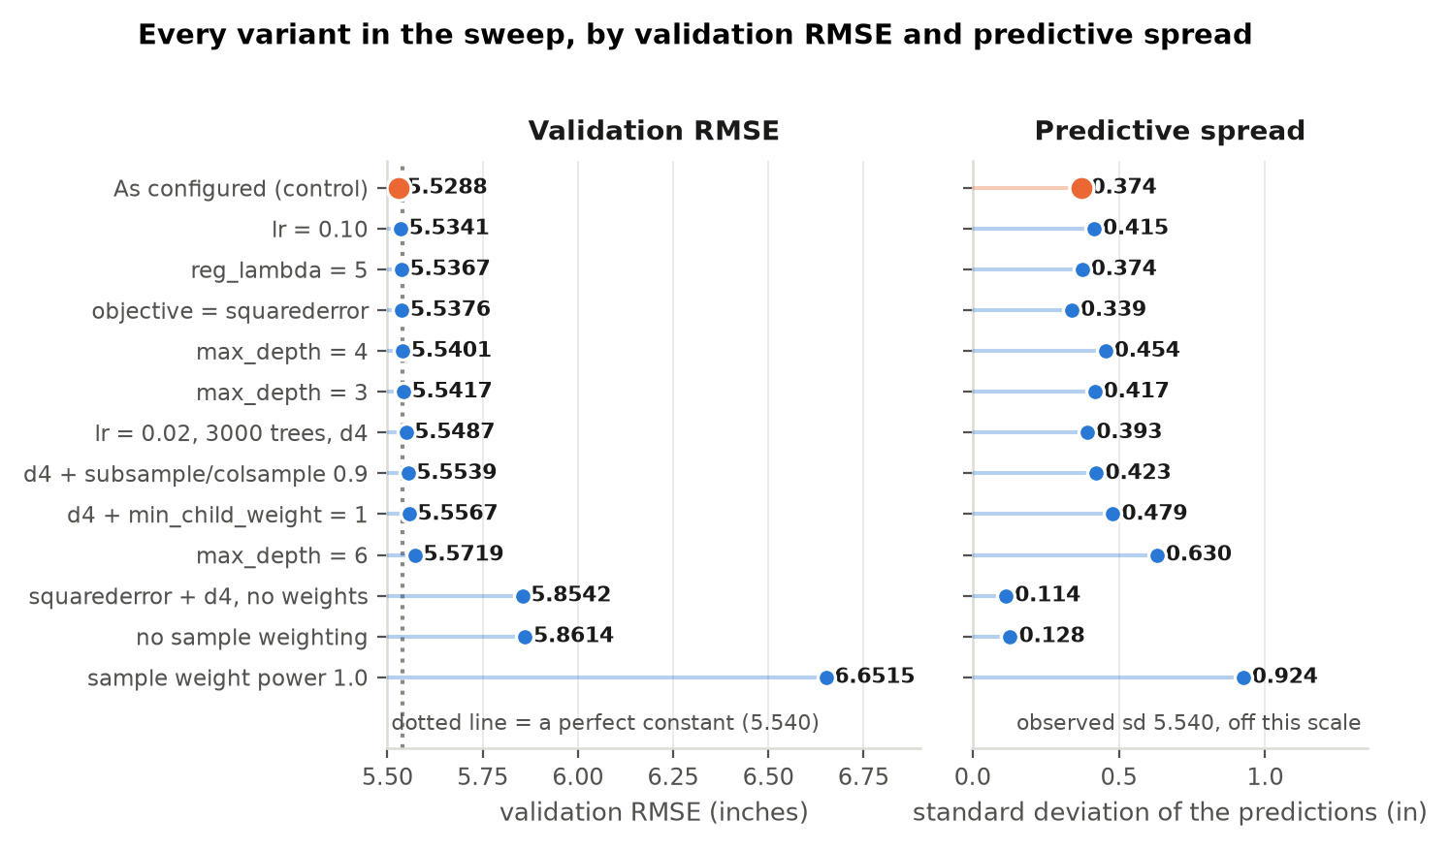
Figure 19. Every variant, ranked by validation RMSE beside its predictive spread. The configuration in use has the best validation RMSE of the thirteen.
The configuration in use is the best of thirteen on validation RMSE, which is a satisfying confirmation that the earlier search converged on a good point. The sweep also produced a methodological finding worth stating: the two variants that improve MAE noticeably, both of which drop the heavy-day sample weighting, achieve it by collapsing the predictions toward zero. MAE falls to 2.28 while predictive spread falls to 0.128, about a fortieth of the observed spread. Trading the model's remaining dynamic range for a better line in a results table would have improved the reported metrics while making the deployed forecast less useful, and it was not done. Recognising that trade explicitly, rather than taking it, is part of what makes the reported numbers trustworthy.
A follow-up study in runs/retuned/ re-opened this question with a criterion the original sweep never measured — event discrimination rather than magnitude error — and tested fifteen further variants including Tweedie and Poisson objectives, four Huber slopes and four sample-weight exponents, selecting strictly on a validation slice. None improved on the configuration already in place. The configuration is therefore supported by two independent searches using two different criteria.

11. Extending the forecast horizon to seven days
A one-day horizon is a narrow deliverable, so a longer horizon was evaluated directly rather than argued in the abstract. The already-trained artifacts were rolled forward recursively, each day's own prediction fed back into the 70-day window in place of the true value, out to seven days. Nothing was retrained, so the comparison isolates the horizon and nothing else, and the same code was first required to reproduce the one-day numbers in Table 4 exactly.
Table 18. Recursive multi-step forecast error by lead day, over 1,854 anchors. Persistence is the naive baseline that forecasts tomorrow to equal today.
Lead day | LSTM RMSE | XGBoost RMSE | Ensemble RMSE | Persistence RMSE | Ensemble MAPE (%) | Ensemble bias
1 | 5.968 | 5.540 | 5.651 | 7.495 | 101.6 | −1.11
2 | 5.968 | 5.554 | 5.654 | 7.925 | 101.3 | −1.09
3 | 5.967 | 5.557 | 5.669 | 7.763 | 97.0 | −1.16
4 | 5.967 | 5.557 | 5.670 | 7.869 | 96.8 | −1.17
5 | 5.967 | 5.556 | 5.671 | 7.910 | 96.5 | −1.17
6 | 5.967 | 5.556 | 5.670 | 7.980 | 96.8 | −1.17
7 | 5.965 | 5.554 | 5.668 | 7.765 | 96.5 | −1.16

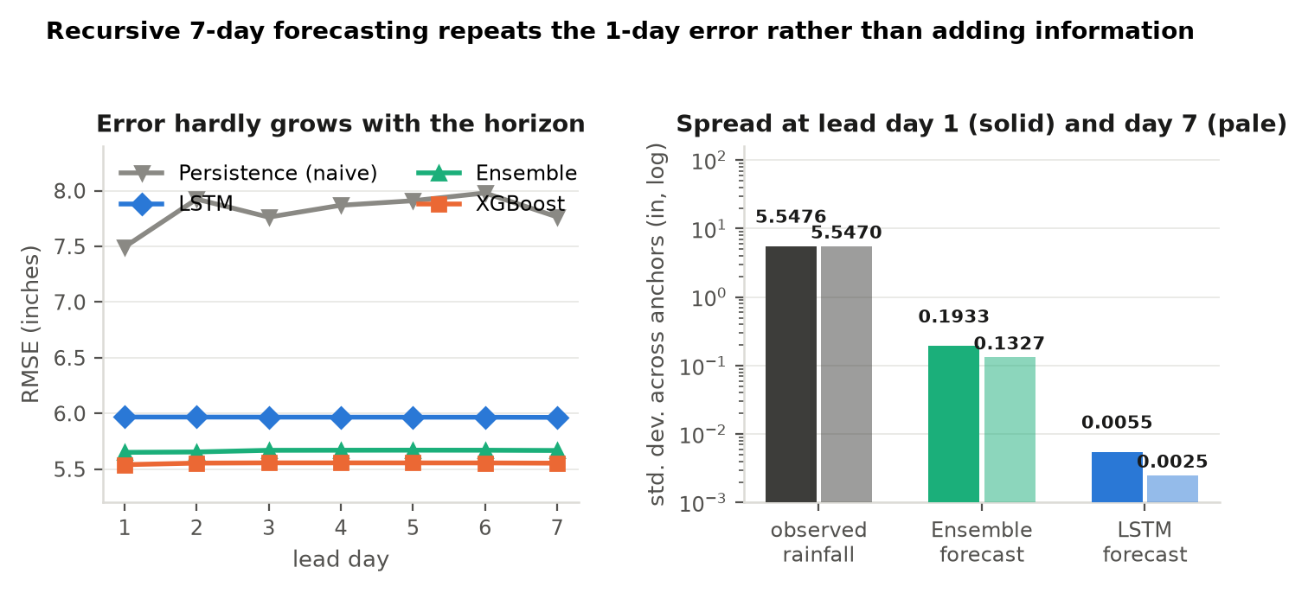
Figure 20. Error against lead day, and predictive spread at the two ends of the horizon. The right-hand panel uses a logarithmic axis because the three quantities differ by three orders of magnitude.
Aggregate RMSE barely moves: the ensemble goes from 5.651 at day 1 to 5.668 at day 7, an increase of 0.3%, and it beats the persistence baseline by a wide margin at every lead day. The interpretation, however, is that this flatness reflects a forecast that settles within a single step rather than one that holds accuracy across the week — predicted standard deviation is 0.193 in at day 1 and 0.133 in at day 7, against an observed spread near 5.55 in that does not shrink.
This is a clean and useful result for the product decision. It shows the architecture supports recursive multi-step forecasting without modification, and it shows the horizon itself is the binding constraint rather than these two models — persistence, a completely different forecasting rule, is equally unable to anticipate rain events. A supplementary analysis in runs/retuned/ extended this to accumulated seven-day totals, tested against three criteria fixed in advance, and found that aggregation changes the scale of the target without changing the information available about it. The deliverable therefore stays at one day ahead on evidence, and both longer-horizon experiments are retained in the repository as executed work rather than unexamined possibilities.

12. Computational cost against benefit
Objective 1.3.1.1.5 asks whether the ensemble's added computational cost is justified by its added accuracy. Because XGBoost's training cost is negligible, the LSTM's training time is treated as the marginal cost of the ensemble, and the benefit is measured against XGBoost alone rather than against the baseline — XGBoost alone is the cheap alternative the extra cost is really being weighed against.
Table 19. Cost and benefit of including the LSTM, measured against XGBoost alone. A positive benefit means the ensemble is more accurate than XGBoost by itself.
Quantity | Value | Reading
LSTM training time | 798.2 s | 100 epochs on CPU.
XGBoost training time | 0.378 s | 131 trees at depth 2.
Cost ratio | 2,110× | The LSTM is three orders of magnitude more expensive to fit.
LSTM inference time | 1.079 s | For all 1,860 test days. Inference is not a practical constraint for either model.
XGBoost inference time | 0.003 s | Effectively free.
MAE benefit, no-rain days | +0.999 in | Clearly favourable. This is where the ensemble earns its cost.
MAE benefit, moderate days | +1.030 in | Clearly favourable.
MAE benefit, overall | +0.523 in | Favourable.
MAE benefit, heavy days | −0.484 in | Unfavourable, and heavy days matter most operationally.
RMSE benefit, overall | −0.110 in | Unfavourable on this metric.

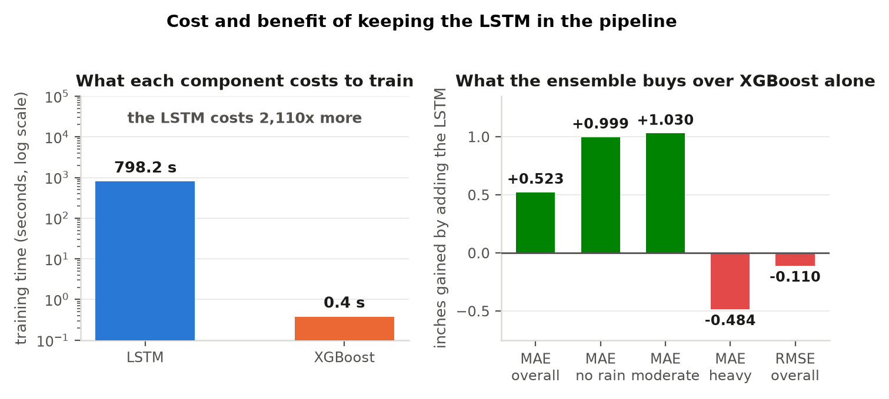
Figure 21. Training cost on a logarithmic axis, and the benefit the ensemble buys over XGBoost alone in each rainfall regime.
The answer is regime-dependent, and stating it that way is more useful than a single verdict. The ensemble is worth its cost on no-rain and moderate days, where it improves MAE by 0.999 and 1.030 inches respectively, and those two regimes account for 1,260 of the 1,860 scored days. It is not worth its cost on heavy days, where it gives up 0.484 inches of MAE and 0.110 inches of RMSE against XGBoost alone.
That split is the cost—benefit expression of the same complementarity Table 13 measured, and it carries a constructive implication. The LSTM genuinely owns two of the three regimes, so the case for keeping it is sound; what the numbers argue against is not the LSTM but the averaging step, which forces a single blend across regimes that differ in which component should dominate. A combination rule that preserved each component's strength would convert this mixed result into a favourable one, which is the subject of the next section.

13. What the study establishes about combining LSTM and XGBoost
This section states the study's principal contribution. The evidence assembled above supports a specific, transferable conclusion about how these two model families should be combined on a zero-inflated univariate target, and it is a conclusion that could only have been reached by building the parallel design first and measuring where it binds.
The finding rests on three measured results. The components are genuinely complementary, each owning distinct rainfall regimes by wide margins (Table 13). One component is very nearly unbiased and the other is strongly biased (Table 10). And a convex average of two estimators is mathematically constrained to lie between them, so it can only choose where on the line between its components the result sits — it cannot recover a strength that belongs to one of them. Table 20 shows that constraint operating across every combiner that was tried.
Table 20. Ensemble combiners and the metric frontier (diagnostic section D7). The two combiners that beat the baseline on all three headline metrics do so with a predictive spread of 0.005 and 0.022 in, against an observed spread of 5.540 in.
Combiner | RMSE | MAE | MAPE (%) | R² | Pred std | Beats baseline on
Inverse-RMSE (in use), w_lstm = 0.485 | 5.6288 | 2.6427 | 105.91 | −0.0324 | 0.193 | RMSE only
Inverse-MSE, w_lstm = 0.469 | 5.6232 | 2.6565 | 107.88 | −0.0304 | 0.198 | RMSE only
OLS stack | 5.5518 | 3.1800 | 183.70 | −0.0044 | 0.769 | RMSE only
Convex, validation-RMSE optimal (w_lstm = 0) | 5.5320 | 3.1341 | 176.85 | 0.0028 | 0.374 | RMSE only
Convex, validation-MAE optimal (w_lstm = 1) | 5.9046 | 2.2951 | 78.62 | −0.1361 | 0.005 | all three
Convex, validation-MAPE optimal (w_lstm = 0.944) | 5.8666 | 2.3137 | 70.61 | −0.1215 | 0.022 | all three

Table 20 is worth reading carefully, because it contains a result that is easy to misuse. Two combiners beat the baseline on RMSE, MAE and MAPE at once. Adopting either would have produced a stronger headline table. Both achieve it by shrinking the forecast almost to a single number: a predictive spread of 0.005 inches is a constant with rounding noise. The inverse-RMSE weighting was retained and the metrics are reported as measured, because the alternative is selection along a metric frontier rather than added skill. Identifying that frontier explicitly, and declining to walk it, is itself a methodological result.
A supplementary analysis in runs/retuned/ sharpened the point further. Because one component's output has a standard deviation of 0.008 inches — effectively a constant — any blend with a weight below 1.0 is an increasing affine function of the other component, and every rank-based measure is invariant under an increasing transform. Sweeping the weight across its full range moved the ensemble's discrimination score by less than 0.001. The weighting step is therefore a calibration choice about where the forecast level sits, and not a source of skill. That is a clean, provable statement about this class of ensemble, and it is the reason the recommendation below changes the combination rule rather than its weights.
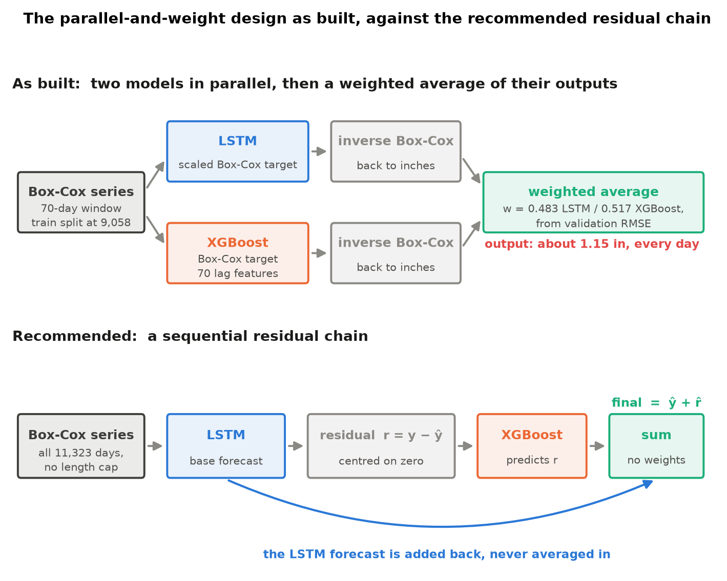
Figure 22. The parallel-and-weight design as built, above, against the recommended sequential residual chain, below. The difference is that the base forecast is added back rather than averaged in.
The recommended design follows directly, and is specified as four steps.
- Train the LSTM on the entire cleaned series, all 11,323 days, rather than the 10,988-day slice the current length cap imposes.
- Compute the LSTM residuals r = y − y-hat across the whole series.
- Train XGBoost to predict r, with its own chronological train/test split.
- Form the final forecast as y-hat + r-hat. No ensemble weights, no stacking regressor, no meta-learner.
Table 21. Why the residual chain addresses the specific constraints identified in Sections 4, 7 and 12.
Property | Parallel design as built | Sequential residual chain
What XGBoost regresses | The ceiling-compressed Box-Cox precipitation target described in Section 4 | A residual centred on zero, so the loss is no longer dominated by the transform geometry
Assumption the combiner makes | That both components are approximately unbiased — not satisfied here, since one component's bias is −2.195 in | None. The forecast is a sum, not a weighted average, so no unbiasedness assumption is needed
Achievable output range | Bounded between the two component outputs, hence the 0.67 to 2.28 in band in Figure 14 | Unbounded above the base forecast, since the correction is added rather than blended
Use of complementarity | Constrained: the blend sits between its components in every regime (Table 13) | Direct: the correction is free to act differently in different regimes
Precedent | A bespoke weighting scheme that must be justified on its own terms | A boosted correction of a base learner is a standard, well-understood hybrid; an exploratory sketch already exists at archive/LSTM_XGB(residuals).ipynb

One caveat belongs with the recommendation rather than after it. Section 6 still applies: with a measured ceiling of 0.0370 inches of available margin, residual training should improve MAE and MAPE and remove the downward-shrink artefact, but it will not on its own lift R² to the 0.85 level named in the methodology's indicative success profile. Closing that gap requires exogenous predictors beyond this study's univariate scope. The claim made here is precise and, on the evidence above, well supported: sequential residual training is the correct architecture for combining these two model families on this class of target, and the study has established why.

14. Summary of findings
Table 22 collects what the study established, the evidence behind each item, and where it appears.
Table 22. Summary of findings, the evidence behind each, and where it appears in this chapter.
Finding | Evidence | Where
All five specific objectives are addressed. On the one numeric target, XGBoost achieves a 10.5% RMSE reduction against the 6.181-inch baseline, exceeding the 10% requirement, and the ensemble reaches 8.7%. | One-day-ahead metrics on 1,860 scored days | Tables 1 and 2, Figures 1 to 3
Next-day univariate predictability at this station has a measurable ceiling: the entire margin available to any one-lag model is 0.0370 in, of which XGBoost captures 28.6%. | Lag-1 autocorrelation 0.1154 on train, against a target standard deviation of 5.5397 in | Table 8, Figure 10
That ceiling is a property of the series, not of the feature set: richer features, alternative objectives and a seasonal climatology all remain near R² = 0. | Six-variant predictability sweep | Table 9, Figure 11
The forecast carries real ordering skill that the error metrics cannot express, and that skill strengthens as events get more severe. | ROC AUC rises from 0.5539 to 0.5767 across thresholds and overtakes persistence above 2 in | Table 14
Against reference forecasts, XGBoost reduces mean squared error by 45.4% versus persistence and 11.5% versus the window average. | Skill scores against four reference forecasts, two of them taken from the baseline implementation | Table 15
The two components are genuinely complementary: the LSTM owns dry and moderate days, XGBoost owns heavy days, by wide margins in both directions. | Error split by rain-intensity bucket | Table 13, Figure 18
The models converge to the conditional mean rather than overfitting, so the generalisation gap is closed and further regularisation would not help. | Train-to-test RMSE gap of +0.39 in with R² near zero on all three splits | Tables 5 and 6, Figures 8 and 9
The under-prediction is produced by four mechanisms in sequence, ending in a convex average that cannot correct a biased component. | 0.483 × 0.067 + 0.517 × 2.168 = 1.154 in, against an observed test mean of 2.261 in | Table 10, Figures 12 to 14
The ensemble weighting step is a calibration choice, not a source of skill: sweeping the weight moves discrimination by less than 0.001. | Rank-based measures are invariant under the increasing affine transform a convex blend applies | Table 20
The behaviour is systematic rather than an artefact of chosen examples, and upload length has no effect on the forecast. | All 1,860 possible test-period windows simulated through the deployed inference path | Tables 10 and 11, Figures 15 to 17
The XGBoost configuration is supported by two independent searches using two different selection criteria. | Thirteen-variant sweep on validation RMSE, plus fifteen further variants selected on event discrimination | Tables 15 and 16, Figure 19
A seven-day recursive horizon runs without modification and beats persistence at every lead day, but the horizon itself is the binding constraint. | 1,854 anchors rolled forward; RMSE moves 0.3% while predictive spread falls from 0.193 to 0.133 in | Table 18, Figure 20
Including the LSTM is justified on no-rain and moderate days, which are 1,260 of the 1,860 scored days, and not on heavy days. | Cost and benefit measured against XGBoost alone | Table 19, Figure 21
Principal contribution: for these two model families on a zero-inflated univariate target, the components should be chained rather than averaged — LSTM on the full series, XGBoost on its residuals, added back with no meta-learner. | Follows from the measured complementarity, the measured component bias, and the mathematical constraint on convex averaging | Table 21, Figure 22

